Schizophrenia Society of Canada  (SSC) since 1979  Serving more than just  Schizophrenia!  Vision  To improve the quality of life and to promote a dignified, non-discriminatory quality of life for those affected by mental illness and addiction; using education and support programs.  The Schizophrenia Society of New Brunswick- (SSNB) is a non-profit community-based organization that was first developed in 1986 as a family support group under the name “Family and Friends” and joined SSC in 1994.  SSNB was incorporated in 1993 |  | SSNB PROGRAMS & SERVICES  Care-Giver Support Group is an informal on-going support group available to the families and primary caregivers of those affected with a long-term mental illness or addiction.  Strengthening Families Together is a 6-10 session family education course for families/caregivers and friends of those coping with mental illness/addiction.  J. Dean McAllister Memorial Bursary is awarded annually to a high school graduate pursuing a career in one of the selected social sciences. Applications must be received prior to May 25.  ACHIEVES literacy and Numeracy is an educational program specifically tailored for persons who have experienced a mental health/addiction disorder and are now coping well enough to try a new challenge through learning skills or upgrading skills lost through trauma.  ACHIEVES Employment Skills is a valuable tool in teaching employment skills to those recovering from a mental illness/addiction. Our mission is to provide support and training in the participants journey to gaining meaningful employment and achieving self-sufficiency.  Your Recovery Journey is a valuable resource for those affected by metal illness who are looking for  helpful tools to assist them in their recovery. Recovery is a practical concept it works in real life, with real people… (Michael Kirby Chair Mental Health Commission of Canada) | Anxiety  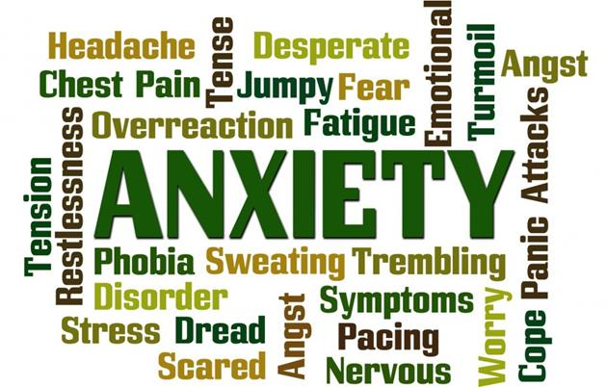  A Reason to Hope  The Means to Cope!  - Schizophrenia Society of New Brunswick  - Tel: (506) 622-1595  - Email: ssnbmiramichi@gmail.com

Common Symptoms of Anxiety  - Feeling nervous, restless or tense  - Having a sense of impending danger, panic or doom  - Having an increased heart rate  - Breathing rapidly (hyperventilation)  - Sweating  - Trembling  - Feeling weak or tired  - Trouble concentrating or thinking about anything other than the present worry  - Having trouble sleeping  - Experiencing gastrointestinal (GI) problems  - Having difficulty controlling worry  - Having the urge to avoid things that trigger anxiety  There Is Hope  With early diagnosis, intervention and treatment, people can recover and lead fulfilling lives.  Employment strategies, as well as, local support groups are available | Types of Anxiety  - Specific phobia (fear of flying…)  - Generalized anxiety  - Panic disorder (Recurrent, unexpected panic attacks) flashbacks  - Agoraphobia (Fear of panic attack in public, where escape is difficult)  - Social phobia  - Obsessive compulsive disorder (Obsessions and compulsions)  Causes of Anxiety  The causes of anxiety disorders aren't fully understood. Life experiences such as traumatic events appear to trigger anxiety disorders in people who are already prone to anxiety. Inherited traits also can be a factor.  Medical causes  Examples of medical problems that can be linked to anxiety include:  - Heart disease  - Diabetes  - Thyroid problems, such as hyperthyroidism  - Respiratory disorders, such as chronic obstructive pulmonary disease (COPD) and asthma  - Drug misuse or withdrawal  - Withdrawal from alcohol, anti-anxiety medications (benzodiazepines) or other medications  - Chronic pain or irritable bowel syndrome  - Rare tumors that produce certain fight-or-flight hormones  Sometimes anxiety can be a side effect of certain medications. | Did you know?  Anxiety disorders can start at any age, but they often begin with “shy” children and teens or in early adulthood. They can also be triggered by a series of traumatic events.  Anxiety disorders in some individuals may lead to diagnosable mental health disorders- i.e. depressive mood disorder, substance abuse, or personality disorder  Women are 16% more likely to experience anxiety than men.  Anxiety varies in severity and can range for a mild uneasiness to a panic attack. It can last for minutes, days, months, or even a lifetime.  Some people develop ways of reducing their anxiety that cause more problems. For example, people with phobias avoid anxiety-provoking situations. This avoidance reduces the anxiety in the short term, but long term can restrict education, work, recreation and social activities

