Bursary Application Guidelines

VALUE $500.00

The applicant must be:

- Graduating from:

- Miramichi Valley High School
- Carrefour Beausoleil
- James M. Hill High School
- Blackville High School
- North and South Esk Regional

- Entering University or Community College with a preference in Social Sciences

The following criteria will be
considered:

- Need
- Involvement in the community and extra curricular activities

Application forms are available at the
guidance office of any school listed
above or at the Schizophrenia Society
of New Brunswick – Miramichi Chapter.

Applications must be

received by May 26th, 2023

Miramichi Chapter

1756 Water Street, Suite 103
PO Box 562, Miramichi, NB E1V 3T7
Tel: (506) 622-1595
Fax: (506) 352-0180

Website
www.schizophreniasociety.nb.ca

E-mail
ssnbmiramichi@gmail.com

Education Available

Family Recovery Journey-(Formerly Strengthening Families Together)
Education Course caregivers and friends of those living with addiction or mental illness

Your Recovery Journey
Education program for people living with addiction or mental illness

Your Mental Wellness Journey

Please call to register
Also available:
Information on Schizophrenia, Bipolar, Depression and anxiety

Charitable Reg. #88609 1495 RR0001

Information provided is subject to change without notification

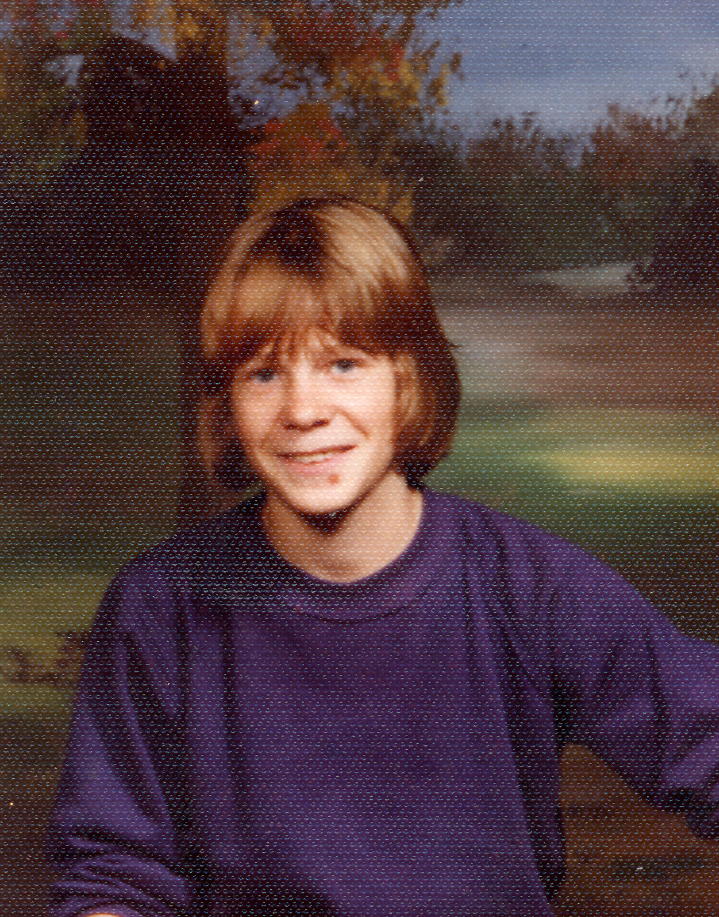

J. Dean McAllister Memorial Bursary

A bursary dedicated to the
memory of J. Dean McAllister
is awarded annually to a
high school graduate pursuing
a degree in the field of
Social Sciences.

All applications must by
received by May 26th, 2023

Sponsored by:

Schizophrenia Society
Of New Brunswick Inc.
(SSNB) - Miramichi

History of

J. Dean McAllister

As a child, Dean loved hunting and fishing. He was a son, grandson, brother and a friend to many but at an early age in life, Dean became involved with drugs and alcohol. There is a lingering thought in my mind (which I, his mother, feel that I must mention) that this might have triggered the schizophrenia. It has not been proven as such, although if drugs and alcohol are taken with this disease, it will delay the progression of recovery.
In 1985 Dean was diagnosed as having paranoid schizophrenia and had been hospitalised most of the time.
Unfortunately, on September 16, 1989 at the age of 25, the disease got to be too much for Dean and he died by suicide. It happened while he was hospitalised at Centracare in Saint John. It was a shock but not a surprise. If there is such a thing as bad timing, this was it because it happened to be the day after I remarried.
At first, I blamed myself but I didn’t keep that guilt for long. I knew I did every possible thing I could do as a mother. I suffered right along with Dean. I could feel his pain and when this happened, it was a relief to know that he was now at peace. He is not suffering anymore. I describe this disease as Hell on Earth.
10% of all people with schizophrenia die by suicide – either to escape the torment of their illness or because their “voices” command them to. I believe this to be true in Dean’s situation.

Revised 2008
      - Vera Taylor

In Memory
of
J. Dean McAllister

Dean was a man whose path was too steep but forever his memory we want to keep

Dean suffered with mental illness that would not cease

He took his life to escape the horrors of this disease

Dean’s death was tragic but we must try to turn it around

Try to find light amid sadness so profound

Each September we have a book fair to raise money and awareness

To help fight stigma and to bring hope and fairness

Our Schizophrenia Society set up a bursary in his name

To help a student in their studies of psychology and the brain.

- Fidele Goguen Jr.

SCHIZOPHRENIA – It’s not …….

- A split personality
- Caused by childhood trauma, bad parenting or poverty
- The result of any actions or personal failures of the individual

SCHIZOPHRENIA is ….

- A brain disease – the result of physical & biochemical changes in the brain
- Youth’s greatest disabler – age of onset is usually 16-25 years
- Treatable with medication & therapy
- More common than you think. It afflicts one in 100 people worldwide.

